

**Bangalore Institute of Technology**

**K.R. ROAD, BENGALURU-560004.**

**Department of Computer Science and Engineering**

**DBMS Mini Project Synopsis**

**True Caller Management System**

|  |  |  |  |  |
| --- | --- | --- | --- | --- |
| **USN** | **NAME** | **BATCH** | **PHONE NO** | **E-MAIL** |
| 1BI18CS118 | Raj Kamal | B4 | 6206045049 | rajkamalavenger@gmail.com |
| 1BI18CS069 | Kumar Divyam | B1 | 9608622269 | divyam.achieve178.grids@gmail.com |

Problem Domain: Spam Protection and Security.

Lab In-Charges: K.R. Suneetha, Bhavana K.V., Mahalaxmi, Varshitha KC

< 01-11-2020 >

**2020-2021**

**For office use only:**

**Accepted :**

**To be modified :**

**Rejected :**

**Signature of the Lab In-Charges**

**True Caller Management System**

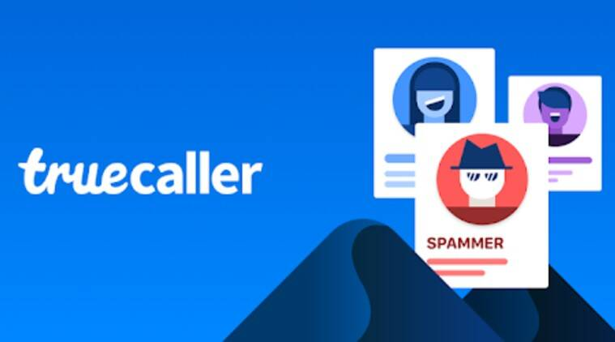

**Problem Statement**

This Project aims to abolish anonymity from the world by allowing people to look up for any unknown number they wish to find by using True caller database.

Goals:

* Create a database for all global working Cellular Numbers.
* Allow users to search for any number belonging to any individual.
* Make users aware of spam Numbers.

It collects the details of user as well as their contacts details to the application. Fundamentally it hold records for all users as well as their contacts. The user can then search for any number available in this database.

**Front end tool**: Html, Css, React.

**Back end tool**: My SQL/My SQL2 ,Mern stack.

E-R Diagram

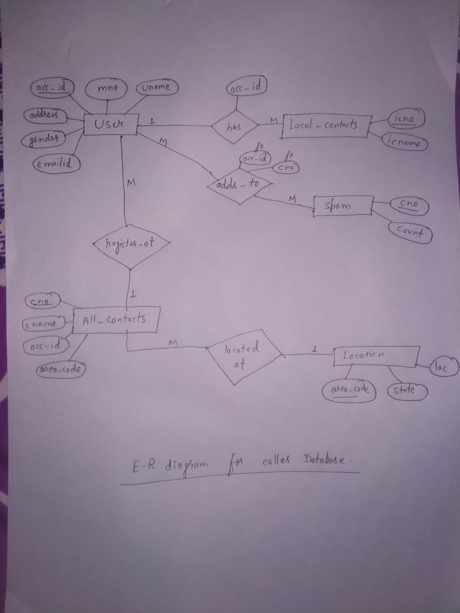

**Schema**

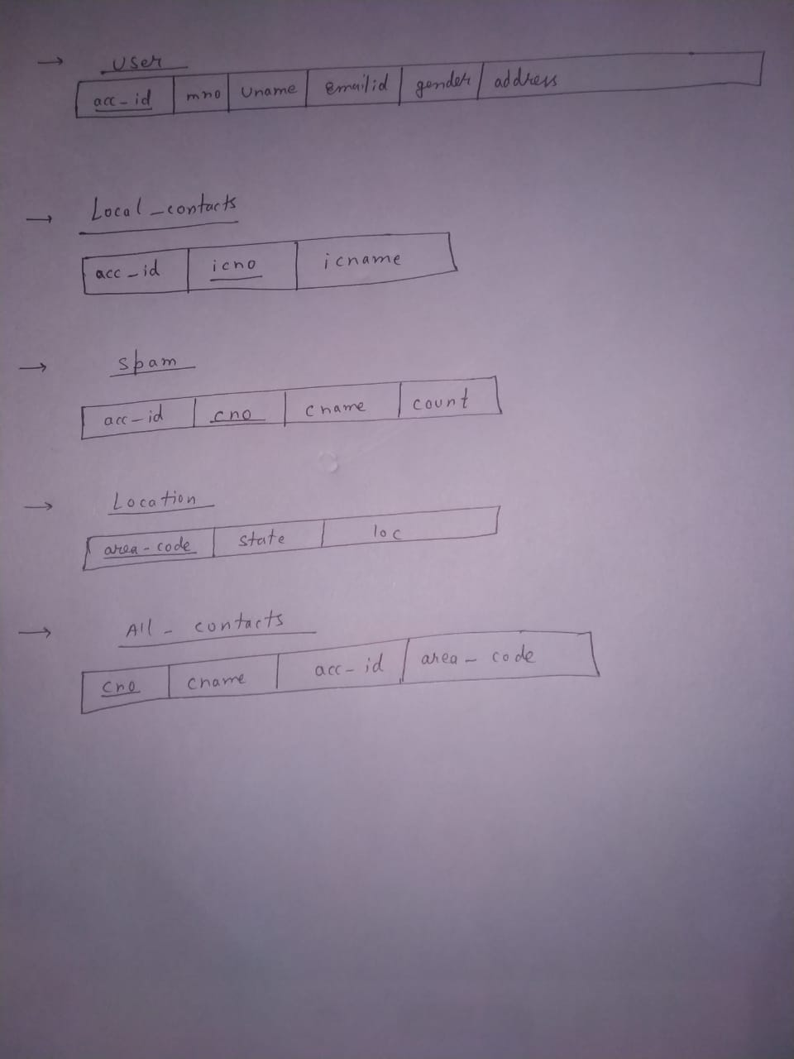

**Modules**

**Login:** The front page for the application, where each user will enter its users id to login.

**Search:** The user will enter Mobile number whose details are to be gathered.

**Spam:** This page will show list of all numbers that are in spam category and also show the number of times each mobile number is reported as spam.

**Contact :** This will be the output page for the searched phone number containing details of the searched number

**Contact list**: This page will show the list of all phone numbers that are in a users contact list.

**Application**

* This database when implement into web based application can be used to identify unknown callers.
* It enables us to know whether a call is authentic or a spam
* It lets us know the number of time a phone number is reported as spam.
* The database is build using crowd-source. To query the database or to use the application the user must enable the application to collect data from its contact list.
* Enables us to know the location of a phone number.